TI FlexPack Booster Pack
Getting Started Guide

- Introduction

The TI FlexPack Booster Pack is designed to bring EMG control to Texas Instruments’ MSP430, C2000, and Tiva-C LaunchPads. The TI FlexPack takes EMG voltages from electrodes and converts the signal into a voltage that is usable by the LaunchPad microcontrollers.

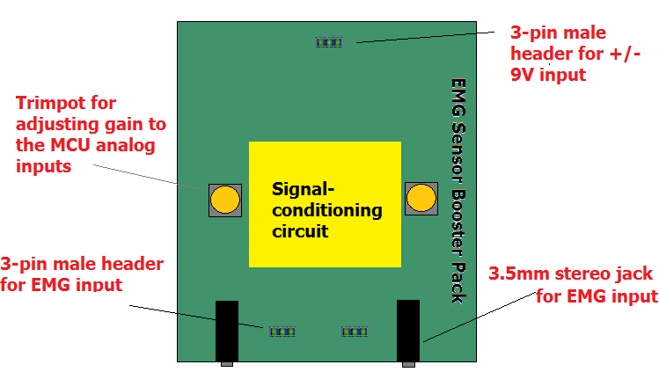
Figure 1. TI Flex Pack Layout

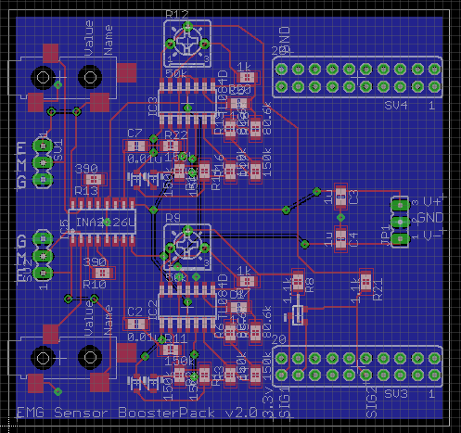
Figure 2. TI FlexPack v2.0 board layout

- Required materials

- Two 9V batteries connected with a 3-position rectangular female receptacle.
- 1 or 2 EMG sensor cables and electrodes (http://bio-medical.com/products/cables/emg-cables.html). EMG sensors can be connected to the TI FlexPack through 3.5mm stereo cables or the 3-pin male headers.

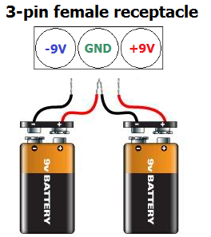
Figure 3. Battery setup

- Electrode placement

The TI FlexPack Booster Pack supports 3 lead EMG cables. One lead (G) is considered ground and the other two (M & E) are potentials. Typical placement for the ground lead is on a boney structure with no muscle (i.e. elbow for forearm or bicep control). The other two leads are to be placed across a muscle of interest (i.e. the M lead in the center of the bicep and the E lead at the end of the bicep). Once the electrodes have been placed, the leads can be connected to the 3.5mm stereo jack or the 3-pin male headers.

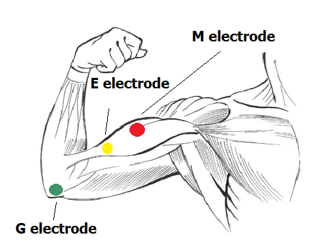
Figure 4. Electrode placement for bicep control

